* x^4 – 7.4*x^3 + 20.44*x^2 – 24.184*x + 9.6448 = 0
* **Muller Method:**

*Output*

Root: 0.8 for starting guess [-1 0 1]

2.2 for starting guess [0 1 2]

>Plots:

-1<=x<=1

**f(x) vs x**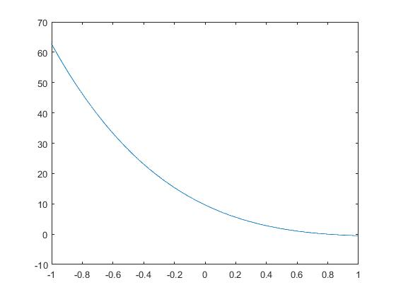

* **Bairstow Method:**

*Output:*

Roots: 2.2, 0.8, (2.2 ± 0.8i) for both sets of values of α0  and α1.

>Plots

0<= x <= 1

**f(x) vs x** 